1. INTRODUCTION :-

COVID-19 spread is emotionally challenging for many people, changing day-to-day life in unprecedented ways. All sections of society should play a vital role to protect themselves and each other and help prevent further spread of the disease. Social-distancing is an important way to slow down the spread of infectious diseases. People are asked to limit their interactions with each other, reducing the chances of the disease being spread with physical or close contact.

In this project, we will start with a theoretical understanding of simple Python, OpenCV, Computer Vision, neural nets and gradually move to Deep Neural Nets and Convolutional Neural Networks. Artificial Intelligence (AI) is that wave sweeping the technology world today. If you want to join this revolution but do not have the skills yet, this series of courses are right for you. In addition to the development of machine learning that leads to new capabilities, we have subsets within the domain of machine learning, each of which offers a potential area of specialization for those interested in a career in AI.

● Neural Networks Neural networks are integral for teaching computers to think and learn by classifying information, similar to how we as humans learn. With neural networks, the software can learn to recognize images, for example. Machines can also make predictions and decisions with a high level of accuracy based on data inputs.

● Natural Language Processing (NLP) Natural language processing gives machines the ability to understand human language. As this develops, machines will learn to respond in a way a human audience can understand. In the future, this will dramatically change how we interface with all computers.

● Deep Learning Deep learning is at the cutting-edge of intelligent automation. It focuses on machine learning tools and deploying them to solve problems by making decisions. With deep learning, data is processed through neural networks, getting closer to how we think as humans. Deep learning can be applied to images, text, and speech to draw conclusions that mimic human decision making. We'll be exploring how to use Python and the OpenCV (Open Computer Vision) library to analyse images and video data. The most popular platforms in the world are generating never before seen amounts of image and video data. Now more than ever it’s necessary for developers to gain the necessary skills to work with image and video data using computer vision. Computer vision allows us to analyse and leverage image and video data, with applications in a variety of industries, Social Distancing, including self-driving cars, social network apps, medical diagnostics, and many more. As the fastest growing language in popularity, Python is well suited to leverage the power of existing computer vision libraries to learn from all this image and video data. We'll start the course by learning about numerical processing with the NumPy library and how to open and manipulate images with NumPy. Then will move on to using the OpenCV library to open and work with image basics. Then we'll start to understand how to process images and videos. Then we'll move on to understanding video basics with OpenCV, including working with streaming video from a webcam. Afterwards we'll learn about direct video topics, such as optical flow and object detection. Including face detection and object tracking. Then we'll move on to an entire section of the course devoted to the latest deep learning topics, including image recognition and custom image classifications. We'll even cover the latest deep learning networks, including the YOLO (you only look once) deep learning network, Fast R-CNN, Retina-NET, Mask R-CNN, Single Shot Detector.

2.1 OVERVIEW

This project covers all this and more, including the following topics:

● NumPy

● Images with NumPy

● Image and Video Basics with NumPy

● Streaming video with OpenCV

● Object Detection

● Template Matching

● Corner, Edge, and Grid Detection

● Contour Detection

● Feature Matching

● Object Tracking

● Optical Flow

● Deep Learning with Keras

● Keras and Convolutional Networks

● Customized Deep Learning Networks

● State of the Art YOLO Networks and much more!

2.2 PURPOSE

The solution is to create a system that uses pre-installed cameras/ recorded videos to analyze images from public areas like shopping malls, streets to see whether the public is adhering to safety measures, like maintaining social distancing.

This project uses python combined with deep learning and computer vision to monitor social distancing. A web application is built and is hosted on the cloud which streams the video of Social distancing Violations

**Project Flow :**

1. Ge the camera / Video Feed
2. Detect pedestrians in the frame using the Yolo pre-trained model
3. Localize the pedestrians in the frame
4. calculate the centroid of the pedestrians detected
5. Find the distance between Pedestrians
6. Draw rectangle bounding boxes around pedestrians who are very close
7. Count the number of bounding boxes which are very near
8. Display the count of Violations on the frame
9. Create a Flask application which streams the frames

3. RESULT

The results of the screenshots are posted below:-

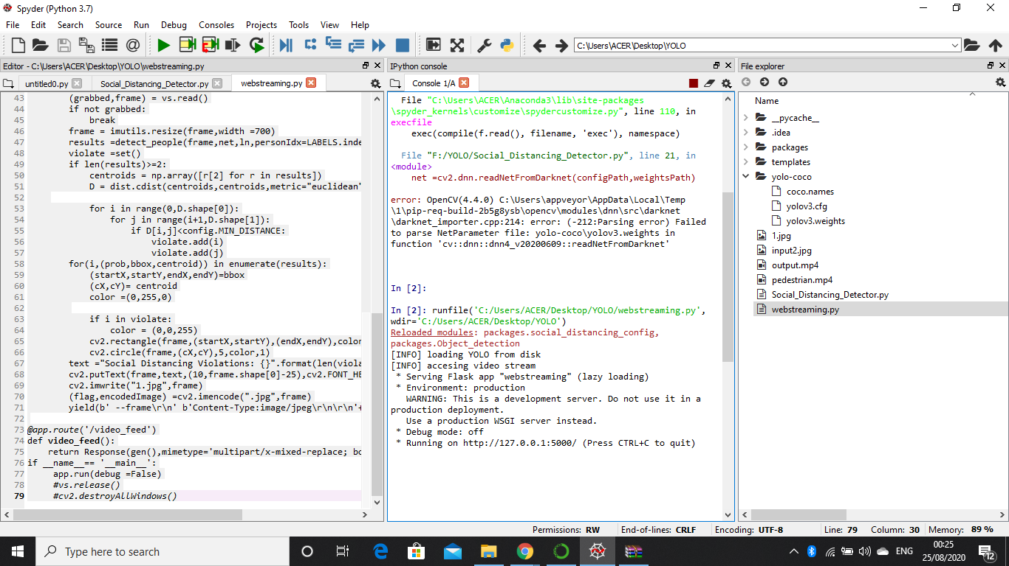

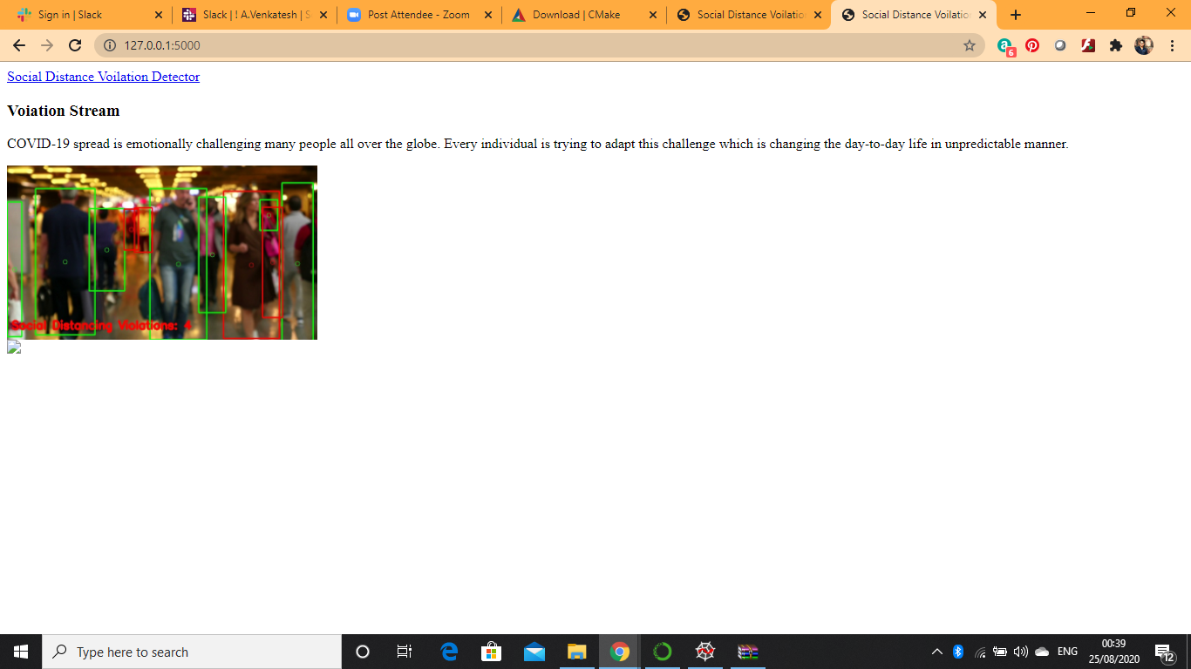

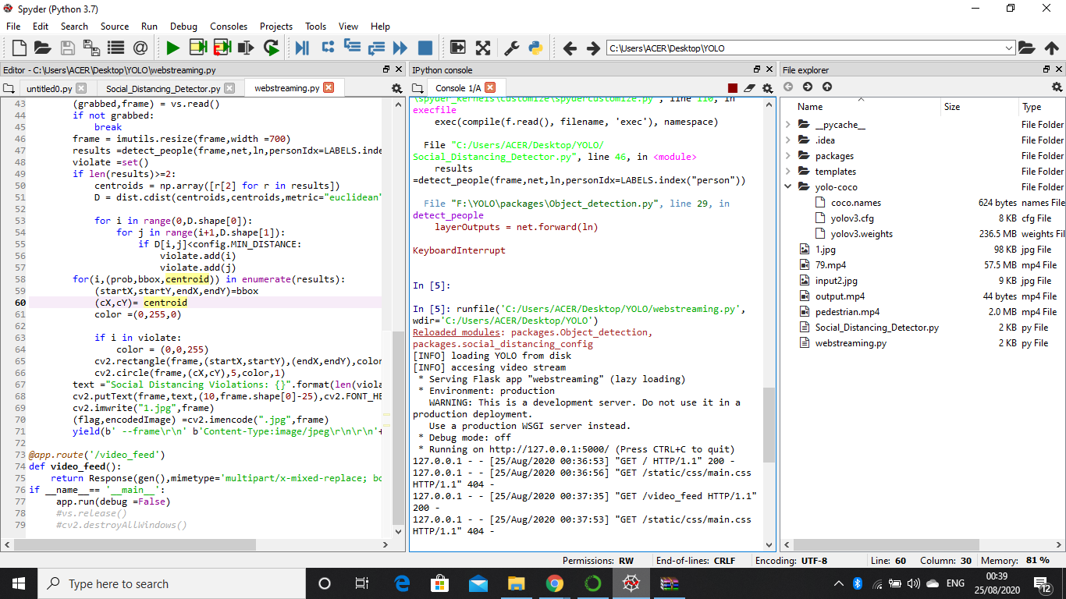

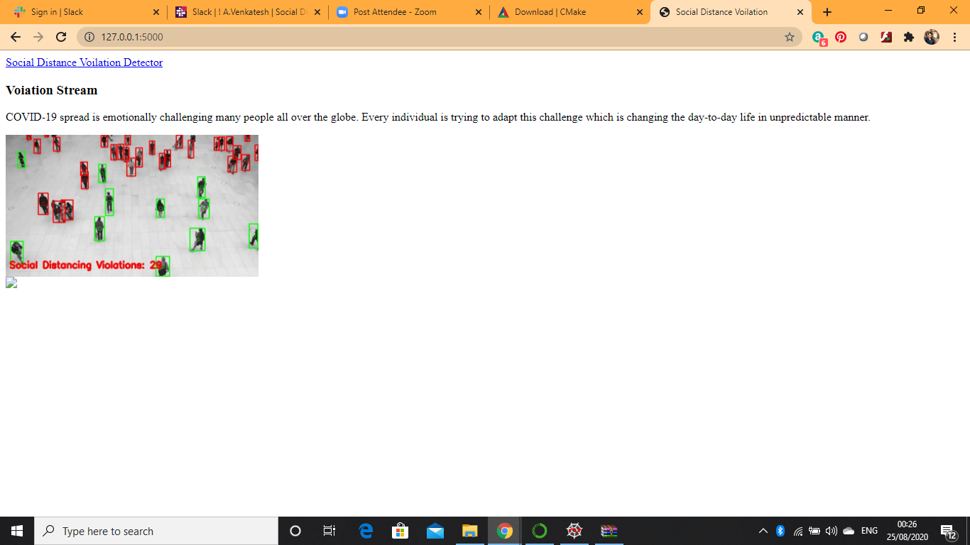

4. APPLICATIONS

Social Distancing Alert System System uses existing IP cameras and CCTV cameras combined with Computer Vision to detect if people are at a specific distance and adhere to social distancing or not.

## Airports

Social Distancing AI App can be used at airports to identify if people are maintaining social distance or not. Multiple IP cameras installed at the airport can capture people standing in close proximity and logs are kept in a system. The app triggers the voice alerts and sends notifications to the concerned authorities.

## Hospitals

Hospitals can use social distancing app to monitor if people are adhering to social distancing or not. Using CCTV cameras installed at hospital premises, health authorities can track if visitors, patients or health workers are maintaining a distance or not. If somebody is found violating the distancing, alerts will be sent to the concerned authorities to take action.

## Offices

The risk of COVID-19 will be not be ending soon; therefore, offices after the lockdown can use this app to ensure that social distancing is maintained until the risk of COVID-19 does not go away. Offices can add face data of their employees and if anyone is found not following distance can receive an alert or notification.

## Manufacturing plants

Social distancing alert device can be used in manufacturing plants to prevent workers from the risk of infection. IP or CCTV cameras installed at the plants would capture and identify if workers are found in close contact with each other. Notification alerts will be sent to the concerned workers and their authorities.

## Retail shops

Retail stores can use the social distancing AI app to ensure that visitors maintain a specific distance from each other. Cameras connected to the app would track the in-store activity and trigger voice alert to aware people. Also, retail stores can integrate a plugin into their website or app to display the live count of visitors in the store so that people can visit the store when the count is less and there is no risk of infection.

## Metro Stations

Metro stations are considered as the most crowded places where the social distancing AI app can help reduce the risk of COVID-19 by alerting people and concerned authorities. Cameras installed at metro stations can use the capability of AI to track the movement of people and find if everyone is maintaining the social distance or not.

## Public libraries

Public libraries can use their existing CCTV or IP cameras to detect if visitors maintain a specific distance while sitting and reading in the library. If people are not found maintaining that distance, the system will trigger an alarm and alert people to create a gap to contain the risk of COVID-19.

## Schools

Using a social distancing AI app, schools can manage social distancing efficiently. If students or teachers are found violating the distancing within school premises, an alert is raised and notification is sent to concerned authorities.

## Religious Places

Religious places like temples and churches can also use the social distancing platform by using their existing cameras. If anyone is found in close contact with another person or group of persons, a voice alarm will trigger and notification will be sent to security guards or concerned authorities.

5. CONCLUSION

The virus that causes COVID-19 is currently spreading easily from person-to-person. When a healthy person comes into contact with respiratory droplets from coughs or sneezes of an infected person, they are can catch the infection.

The World Health Organisation (WHO) states that "COVID-19 is transmitted via droplets and fomites during close unprotected contact between an infector and infectee". A fomite is an object or material which is likely to carry infection, such as clothes, utensils, and furniture. Therefore, transmission of the infection can be avoided by staying away from other people as well as from touching infected fomites.

Social distancing aims to decrease or interrupt transmission of COVID-19 in a population by minimising contact between potentially infected individuals and healthy individuals, or between population groups with high rates of transmission and population groups with no or low levels of transmission.

6. FUTURE SCOPE

Studies on outbreaks of infectious diseases, such as the flu, suggest that social distancing is an effective way to reduce the number of people infected provided that the measures are thorough and that they are continued for a suitable length of time. Studies on the 1918 influenza epidemic, comparing different states in the USA, demonstrated the benefits of applying social distancing.

A recent, systematic review by Fong et al., (2020) "found some evidence from observational and simulation studies to support the effectiveness of social distancing measures during influenza pandemics. Timely implementation and high compliance in the community would be useful factors for the success of these interventions."

## Methods of Social Distancing

#### Prohibition of Mass Gatherings

Cancellation of events which involve large numbers of people gathering together, such as:

* Sports games
* Work conferences
* Theatre productions
* Cinemas

#### Closure of Community Facilities

These facilities can include:

* Swimming pools
* Gyms
* Youth clubs
* Community centres

#### Workplace Closure

* Closure of non-essential workplaces
* Closure of schools
* Closure of colleges and universities

#### Self-Shielding

* Individuals limit face-to-face contacts
* Individuals avoid public places
* Individuals avoid public transport